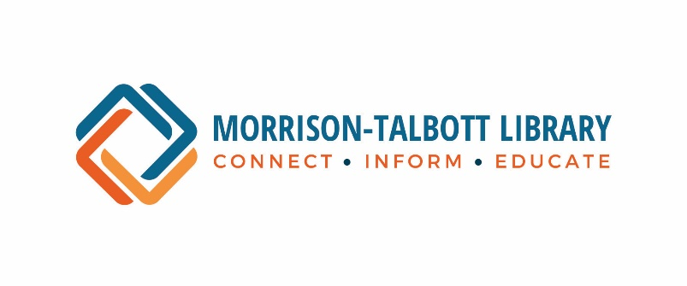
Circulation Assistant I – General

JOB DESCRIPTION:

This is a part-time, permanent position under the direct supervision of the Adult and/or Youth Services Coordinators. Responsibilities include, but are not limited to, patron assistance, reader’s advisory and circulation, assistance with library programs, and support duties on the library's computerized circulation system.

REQUISITE ABILITIES:
Ability to deal tactfully, courteously and professionally with patrons of all ages and with other employees. Ability to work independently without constant supervision. Ability to work in a team environment. Ability to handle confidential information with discretion and tact. Ability to accept and manage change in a fast-paced environment. Flexibility, enthusiasm, sense of humor, attention to detail. General knowledge of and the ability to work with computers and laptops using Microsoft Office and Google Workspace. General knowledge of electronic devices, including but not limited to: smart phones, tablets and e-readers. Ability to learn Polaris/LEAP (Integrated Library System). General knowledge of the Dewey Decimal system.

PHYSICAL DEMANDS:
Lifting up to 40 pounds, carrying less than 40 pounds, typing or keyboarding, stooping, walking, climbing, balancing, kneeling, reaching, hearing, speech, visual acuity.

DUTIES:
- Open and close the library.
- Assist patrons in choosing and locating reading and reference materials, including usage of the library’s online databases and basic genealogical research in person, via telephone and/or email.
- Provide technology assistance and troubleshooting to patrons operating equipment, such as computers, photocopier or microfilm reader.
- Assist and educate patrons downloading library databases and apps.
- Issue new library cards and renewals.
- Staff the circulation desk to check in materials, check out materials, fulfill daily holds, collect payments, register program attendees, accept requests for interlibrary loan materials, and keep daily records.
- Notify patrons that requested materials are at the library to be picked up.
- Process daily delivery of ILL materials.
- Stock library brochures and set up/maintain library displays.
- Clean, repair and maintain library materials.
- Shelve returned materials, and read and straighten shelves.

- Cover books and assist with moving book donations to book sale.
- Assist patrons with faxing, scanning, and photocopying.
- Daily maintenance and emergency maintenance of equipment, such as paper jams.
- Assist in planning and carrying out Library programming for adults and children.
- Run processing reports such as in-transit, in-process and missing items.
- Attend job related workshops and training sessions including keeping up-to-date on all library e-resources.
- Work with student workers and volunteers.
- Perform other related duties as assigned or dictated by work flow.

WORKING CONDITIONS:
This is a part-time position, requiring some evenings and weekends. Occasionally, a split shift may be required.
This position requires the ability to work with computers and equipment such as a microfilm/fiche reader/printer, photocopier, calculator, fax machine, laminator and other electronic devices (smart phones, tablets, e-readers).
An initial evaluation will be performed after a probationary period of 90 days; thereafter, evaluations will be performed on an annual basis.
Attendance at library meetings, training and workshops necessary for job performance and to meet continuing education requirements set forth by the Regional Library System is required. Work with other librarians at the Public Library and at the Regional Library System on committees and cooperative library projects is expected.

BASIC REQUIREMENTS:
High school diploma, or equivalent. Additional relevant education and/or work experience in customer or public service a plus.
Excellent communication skills, ability to maintain productive working relationships with co-workers, a strong commitment to public service, a broad spectrum of interests, and continuing and active interest in reading in a variety of subject areas are essential.
General knowledge of computers, including use of Microsoft Office and Google Workspace, required. Competency with electronic devices (smart phones, tablets and e-readers) required.
General knowledge of the Dewey Decimal system is required.

The Morrison-Talbott Library is an Equal Opportunity Employer.

The intent of this summary is to characterize the typical duties and responsibilities that will be required of individual positions. It is not intended to be an all-inclusive list of the duties and responsibilities of the job described, nor is it intended to be such a listing of the skills and abilities to do the job. Rather, it is intended only to describe the general nature of the job. Employees may be expected to perform duties which are specific to their area that may not be reflected in this summary.

