Morrison-Talbott Library Freedom of Information Act (FOIA) Policy

A brief description of our public body follows.

I. Our purpose is to build community by connecting people to informational resources and educational opportunities to ensure equitable access for all.

2. An organizational chart is attached (see Attachment 1).

3. The total amount of our operating budget for FY 26 is: $745,194.00.

Funding sources are property and personal property replacement taxes, state and federal grants, fines, charges, and donations. Tax levies are:

a. Corporate purposes (for general operating expenditures)
b. IMRF (provides for employees’ retirement and related expenses)
c. Social Security (provides for employees’ FICA costs and related expenses)
d. Maintenance (for maintaining the building)
e. Tort Liability (for insurance premiums, risk management, attorneys’ fees and related expenses, unemployment and workers’ compensation insurance)

4. The office is located at: 215 Park Street, Waterloo, Illinois 62298-1305

5. We have the following number of persons employed:

a. Full-time (4)
b. Part-time (10)

6. The following organization exercises control over our policies and procedures:

The Morrison-Talbott Library Board of Library Trustees, which meets monthly on the 4th Monday of each month, 6:30 p.m., at the library. Its members are: Ken Perkins, President; Amy Grandcolas, Vice President; Kathryn Osterhage, Secretary/Treasurer, and six trustees.

7. We are required to report and be answerable for our operations to:

Illinois State Library, Springfield, Illinois. Its members are: State Librarian, Alexi Giannoulias (Secretary of State); Director of State Library, Greg McCormick; and various other staff.

II. You may request the information and the records available to the public in the following manner:

a. Use request form (see attached).
b. Your request should be directed to the following individual: Jamie Wratchford, FOIA officer.
c. You must indicate whether you have a "commercial purpose" in your request.

“Commercial purpose” is defined in the Act as “the use of any part of a public record or records, or information derived from public records, in any form for sale, resale, or solicitation or advertisement for sales or services.” However, there are exceptions for news media, non-profits, scientific and academic organizations for disseminate news, articles or opinions of public interest, or research or education.

In the event a “commercial interest” is involved, additional questions can be asked of the requestor by the public body FOIA officer in order to determine the classification, then the public body has up to 21 days to respond and either deny the request based on exemptions or undue burden; or estimate the time and cost of the copying for prepayment; or provide the documents requested.

d. You must specify the records requested to be disclosed for inspection or to be copied. If you desire that any records be certified, you must specify which ones.

e. To reimburse us our actual costs for reproducing and certifying (if requested) the records, you will be charged the following fees:

1. There is a $1.00 charge for each certification of records.
2. There is no charge for the first fifty (50) pages of black-and-white text, letter or legal size;
3. There is a $.15 per page charge for copied records in excess of 50 pages;
4. The actual copying cost of color copies and other sized copies will be charged.

f. If the records are kept in electronic format, you may request a specific format and if feasible, they will be so provided, but if not, they will be provided either in the electronic format in which they are kept (and you will be required to pay the actual cost of the medium only, i.e. thumb drive etc.) or in paper as you select.

g. The office will respond to a written request within five (5) working days or sooner if possible. An extension of an additional five (5) working days may be necessary to properly respond.

h. Records may be inspected or copied. If inspected, an employee must be present throughout the inspection.

i. The place and times where the records will be available are as follows: 10:00 a.m. to 5:00 p.m. at Morrison-Talbott Library, 215 Park Street, Waterloo, Illinois 62298.

III. Certain types of information maintained by us are exempt from inspection and copying. However, the following types or categories of records are maintained under our control:

Monthly Financial Statements
Annual Reports
Operating Budgets
Annual Audits
Minutes of the Board of Library Trustees
Library Policies, including Materials Selection
Annual Reports to the Illinois State Library

Attachment 1.

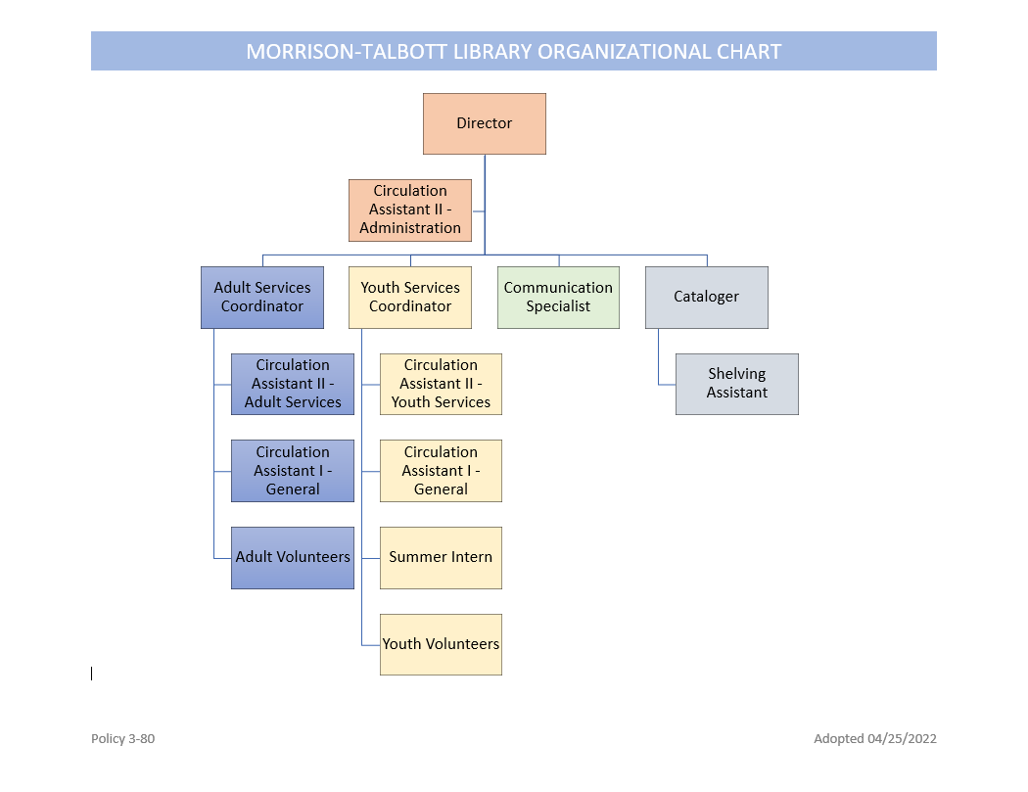

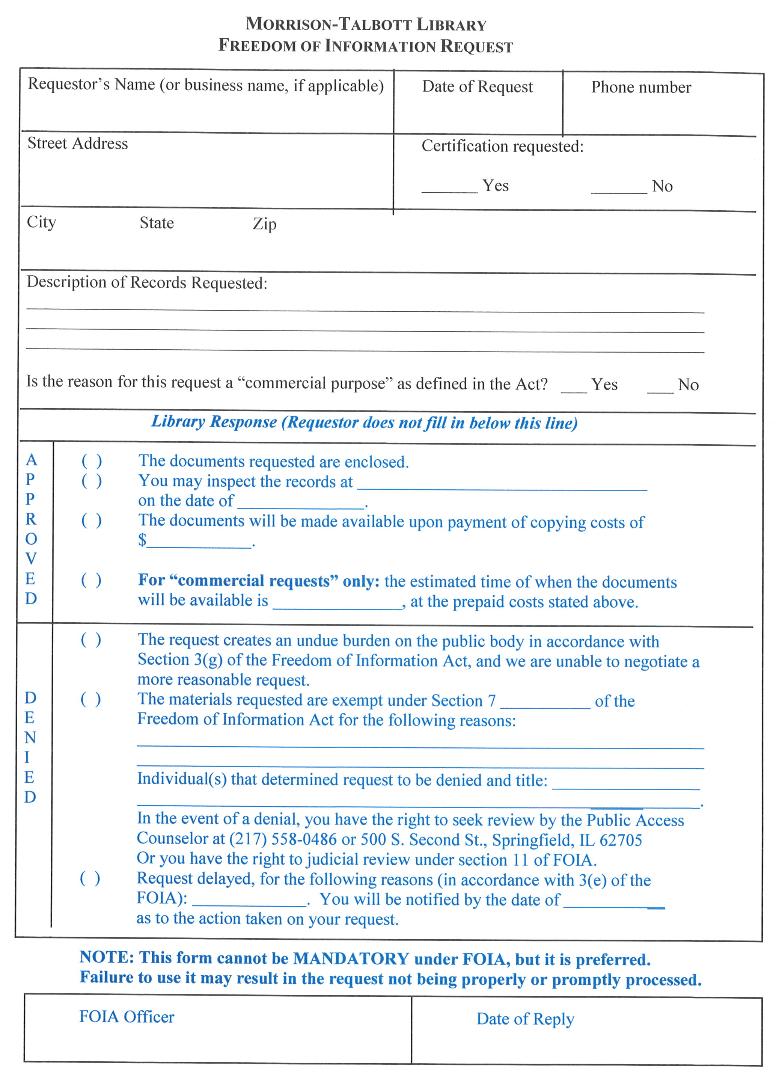
62701

