Morrison-Talbott Library
3D Printer Policy

Morrison-Talbott Library’s 3D printer provides access to emerging design technologies to inspire and help the community bring three dimensional objects to life.

All 3D printing will be performed by designated Morrison-Talbott Library staff members. The public will not be permitted to operate the 3D printer.

The 3D printer may be used only for safe and lawful purposes. The library will not print items that are:
- Prohibited by local, state or federal law.
- Unsafe, harmful, dangerous or pose a threat to the well-being of others.
- In violation of intellectual property rights.
- Likely to fail to print, or to cause damage to the 3D printer.
- Obscene or inappropriate for the library’s environment.
- For resale.

Morrison-Talbott Library reserves the right to:
- Refuse any 3D print request.
- Set time limits for print production.
- Set fees for materials and print production.
- Limit the number of requests.
- Stop print production due to time constraints or equipment capabilities.
- Display print job while in process.
The library cannot guarantee confidentiality of printed designs.
The library cannot guarantee a print job will be ready on a specific day. Patrons will be notified when print jobs are ready for pick up via contact information provided on the print request. Printed items must be picked up within 14 days of the first notice of the project’s completion.
Pricing is based on the final post production weight of the object. Patrons will not be charged for production failures.
By submitting content or objects, patrons agree to assume all responsibility for, and shall hold the library harmless in, all matters related to patented, trademarked or copyrighted materials.
Morrison-Talbott Library is not responsible for any damage, loss or security of data arising from the use of its computers or network, nor for the functionality or quality of content produced on the 3D printer.
Submission of a 3D print file signifies that you have read and accept the library’s 3D Printer Policy.
3D Printing FAQ
Printer name and design space:
Bambu Lab AMS Lite, Model SA005
Designs can be created using Bambu Studio at https://bambulab.com/en/download/studio
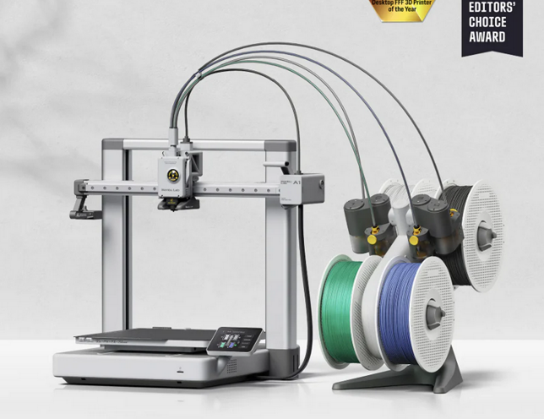
How do I create a design?
There are many web-based programs available. The library uses https://bambulab.com/en/download/studio . You can learn more about 3D design at www.tinkercad.com or by searching the web and You Tube.
How do I get started?
1. Create a .obj or .stl 3D design file; save it on a micro SD card (preferred) or a USB drive.
2. Bring your micro SD card or USB to the library, and complete a 3DPrint Request Form. Or submit your form and design online to MakerSpace@waterloolibrary.org
3. Your design will be reviewed by staff. You will receive a call to discuss estimated printing cost and options.
What colors can I print?
The 3D printer is capable of using 4 colors at a time. You may ask for available color choices when you submit your print request.
You may provide your own filament, but library staff must ensure that it is compatible with our printer. The library has the right to refuse any filament deemed incompatible.

What size can I print?
Designs created at home must not exceed 25MB.
Print size is limited to: 9.5 inches tall by 9.5 inches wide by 9.5 inches deep
Print time cannot exceed 8 hours.
How much does it cost to print an item?
The estimated cost to print your item will be provided to you following your file submission. Printing cost will be calculated by multiplying the grams of PLA filament used times $0.20 per gram plus a $2.00 printing fee.
Example: 10 grams X $0.20 = $2.00 plus $2.00 printing fee = $4.00)
There is a minimum $2.00 charge per item.
We do not charge for prints that fail in production.
Patron must pay this amount before a printed item can be claimed. Payment can be made by cash, check or card. (Additional fee is charged by your bank for credit and debit cards.)
When will my item be ready?
You will be notified by phone or email when your item is ready. The library cannot guarantee completion dates. You must pay for and pick up your item within 14 days of its completion. If item is not picked up, the fee will be added to your patron account, and the item will become the library’s property.
How often can I use the 3D printer?
You are limited to one design submission per week. During times of high demand, the library will only schedule one print job per day. Acceptance and completion of projects is dependent upon staff availability.
The library does not retain design files for future use.
Please Note:
Files will be printed exactly as they are submitted; Staff will not modify any files. You must remove your own rafts and supports.
The library will try to print quality objects from submitted files, but we cannot guarantee that the file will print the way you want. If you need your item to be exact, please use a professional, commercial printer.

